Thankyou for applying for our festival. Please answer all the questions, obviously the last one being the most important as it is likely our best chance fo deciding whether you fit our needs. So please copy and paste links to online music you have on eg Soundcloud, Bandcamp etc. Video from youtube or Vimeo both video you have of specific tracks and live performance will be very helpful.
And Finally good luck with your application.
Best wishes’
Wakefield Music Collective 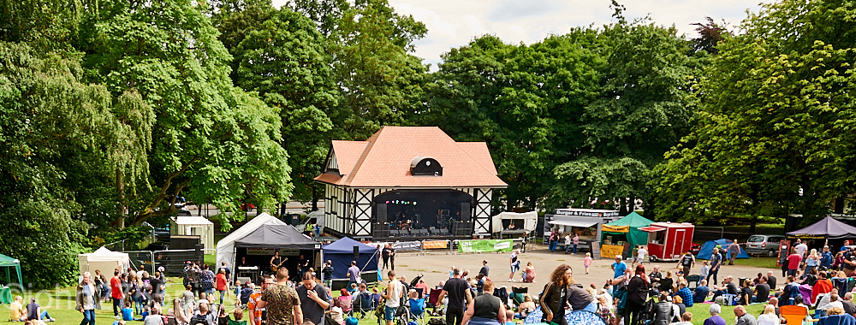

Name (Band Contact):___________________________________________
Band Name / Artist Stage Name: ______________________________________
Email Address: _____________________________________________________
Mobile Number / Land line Number: ____________________________________
Location: ___________________________________________________________
Genre: _____________________________________________________________
Bio and Musical Influences: ____________________________________________
Band Members and Instruments: ________________________________________
Live Gigs last 12 months: ________________________________________________
Links to Online Music (You Tube / Soundcloud etc.) Please copy and paste links:

Please forward this form to info@themusiccollective.co.uk

