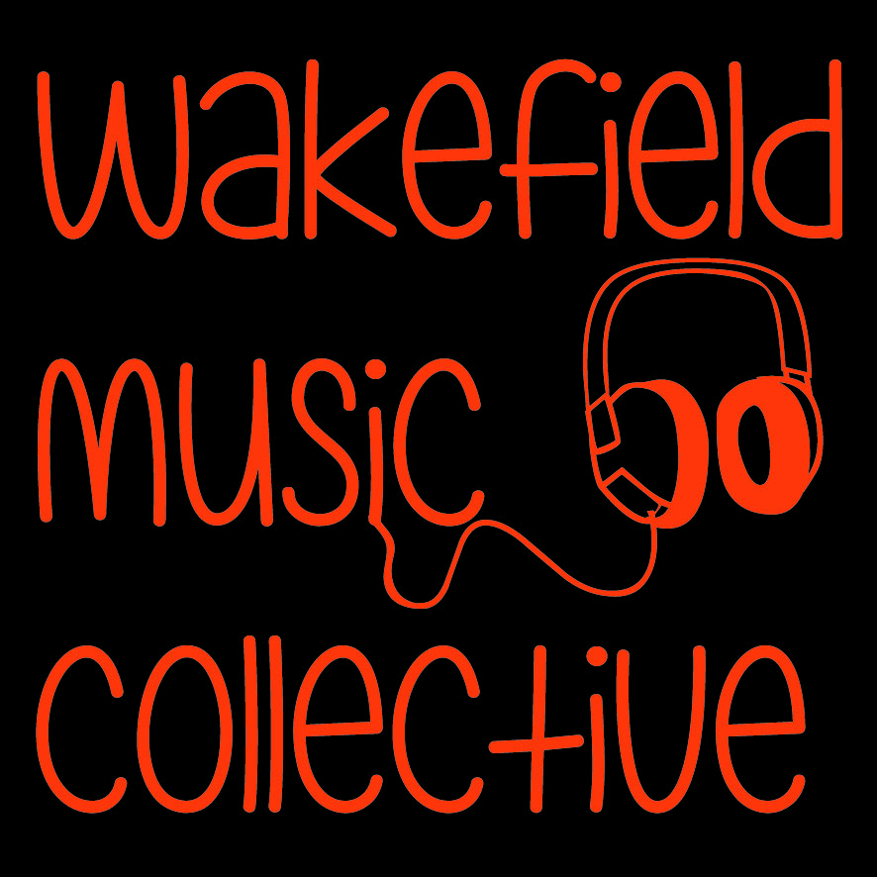

CLARENCE MUSIC FESTIVAL 2018
BARS & ALCOHOL TENDER APPLICATION

2019 is the 28th year of Clarence Park Music Festival, a 2-day event taking place in Clarence Park, Wakefield, West Yorkshire over the weekend of 27th-28th July 2019 and featuring a variety of bands and acts across two stages. This event usually attracts upwards of 5,000 visitors over two days.

Wakefield Music Collective operates the Festival. We are a committee-led not-for-profit organisation based in Wakefield, West Yorkshire, UK.

Please read this information carefully, it is vital for your booking.

REQUIREMENTS

Our aim is to provide a licensed bar area in the Festival grounds (a public park) providing a range of refreshments for attendees at the Festival to enjoy. This tender is for the exclusive right to sell alcoholic beverages.

Opening Hours: The bar must be operational from 11:30am until 9pm on each day of the Festival, and open to the public from 12pm to 8:30pm dependent on licensing restrictions.

Location: The bar will be located to one side of the staging arena in a covered area (the “bar tent”) within the park, sharing the same undercover area as the second stage.

Equipment: The bar provider will be expected to provide all bar furniture and hardware, cash handling facilities, storage equipment, lighting of the bar area, barriers, vehicles, signage and décor.

Licensing: The successful operator will be responsible for obtaining the Licence for the bar area from Wakefield Council Licensing Department.

Insurance: The bar provider will be expected to provide evidence of public and employers’ liability insurance, key contact details, risk assessments and method statements covering all bar operations including setup and de-rig. The bar provider is responsible for their own contents and stock and as-such must ensure there is adequate security and insurance to cover this. Any collection of cash from site should form part of the bar providers risk assessment.

Staff: The bar provider will arrange staff as required to operate alcohol sales and manage stock, cash and waste operations as well as making necessary arrangements to ensure no-one under the age of 18 is served alcohol, and also make arrangements to ensure those who appear to be drunk are not served.

The bar provider will nominate a bar manager who will be on-site throughout opening hours and will take responsibility for meeting relevant requirements of the Licence. The bar manager should be a Personal Licence Holder.

Inclement Weather Provision: The bar provider must ensure there are adequate processes in place in case of poor weather. This includes securing loose items, and provision for making safe the bar area in case of rain.

Water Supply & Waste Disposal: A walk-in site skip is provided for disposal of rubbish. There is a water supply next to the main building which the bar provider may use, however no piping or semi-permanent hook-up may be connected. The main building has a drain which may be used for disposal of liquids. No waste liquid to be poured into the ground or adjacent waterways.

Safety: All drinks sold at bars will be served in plastic bottles with caps removed, or in shatterproof plastic or paper based containers. No glass should enter the public area.

All electrical equipment must carry PAT/electrical safety certification prior to any mains connection. Equipment must be located in a weatherproof area. As far as practicable, all electrical equipment shall be located so that it cannot be touched by members of the public or unauthorised workers.

Setup Times: The bar may be setup on-site from 7pm-9pm on Friday 27th July 2018, and from 7am on Saturday 28th July 2018, no later than 9.00 am. De-rig is authorised from 9pm on Sunday 29th July 2018.

Artwork, Logos & Promotion: In the event of a brewery/venue tie-in, the bar provider’s logo may be added to the poster and advertised in the programme. It is the bar provider’s responsibility to provide the artwork in camera-ready format by the print deadlines advertised by Wakefield Music Collective.

FINANCIAL CONSIDERATION & PROCESS

Fees: Wakefield Music Collective expects the successful operator to make a financial contribution to the Festival. The Fees may depend on non-monetary assistance (see below). Fees are payable upon acceptance of the signed tender contract by bank transfer, and Wakefield Music Collective will provide a pro forma invoice. A deposit of 10% of the fee is required immediately upon acceptance of the tender bid, with the balance of the bid due in cleared funds no later than 1st June 2019.

Non-Monetary Assistance: The bar provider may elect to provide incentives alongside the fee above, which may include the bar tent marquee (no smaller than 12m x 8m), PR and marketing assistance, staging, stage lighting, and other site facilities. We also hold pre-Festival and after-show parties and gigs; venue hire may also form part of this. Please state any non-monetary assistance in section 3.

Selection Process: The successful contractor will be selected on the basis of financial contribution, but Wakefield Music Collective does not bind themselves to accept the highest amount offered. Relevant experience, portfolio and demonstrated expertise in the events sector, ability to meet the requirements set out in this document, commitment to safety and training, past performance and accreditations will be taken into account.

Non-delivery & Cancellation: No refunds or return of deposits will be given in case of cancellation of the event or no-show/late-show by the bar provider.

ENQUIRIES

Enquiries may be made to info@themusiccollective.co.uk or by phoning the event coordinators on 01924 695060 / 07913 170445.

If you choose to make your application in an electronic document, please ensure you provide all the information in full in sections 1 to 5, in particular the text and wording of section 5.

Please return the completed tender form to:

Wakefield Music Collective
16 The Orchard
Ossett
Wakefield
West Yorkshire
WF5 8PP

Or via email to:
info@themusiccollective.co.uk

SECTION 1: COMPANY DETAILS

Company Name

Address

Postcode

Contact Name & Position

Contact Telephone Numbers - landline & mobile and email

SECTION 2: CONSIDERATION

Please detail your setup, including event experience, bar size (frontage and serving area) and variety of refreshments served, and any other requirements.

SECTION 3: NON-MONETARY INCENTIVES

Please use this section to tell us (other than the fee in section 4) what your organisation may also offer in-kind. Examples include a bar marquee, security facilities, staging, lighting, marketing assistance, and crowd control.

SECTION 4: FEE

In consideration of the above, please state the amount your company is tendering to run the alcohol concession at Clarence Park Music Festival 2018 in Pounds Sterling. This is exclusive of in-kind items and will be payable to Wakefield Music Collective upon acceptance of the tender. Please note that Wakefield Music Collective is not registered for VAT.

SECTION 5: DECLARATION

I have read the conditions and confirm my agreement. If my application is successful, I agree to pay the Fee in section 4 above. A binding agreement only occurs when there is written acceptance of the application by Wakefield Music Collective upon which a full contract will be drawn up.

Signed & Dated

